, 2021

Name

Address

Calgary, AB

**Re: Offer of Employment**

Clough Enercore Limited (“**CEL**”) is pleased to offer you casual part time employment on the terms and conditions described in this letter.

The terms and conditions of your employment are as follows:

1. **Position**

You will be employed as a **Title**and will perform the duties and exercise the powers outlined in the current job description for the position (See Schedule “A”). From time to time you may be required, on a temporary basis, to exercise other duties related to your position including some duties which are normally assigned to your peers.

1. **Term**

You will be employed effective **Date** on an indefinite term basis subject to termination as set out in paragraph 7.

1. **Employee Obligations**
2. As a casual employee, you will be asked by the Discipline Lead to work a varied number of days/hours per week. You may elect to work or not to work the hours requested by CEL.
3. CEL’s culture and work practices are committed to a philosophy where our people, practices, systems and culture work together to create quality and value in a safe work environment.
4. As a Casual employee, it is understood that you may be working for other employers during your employment with CEL. We ask that, in order to manage any potential conflicts of interest, you advise us of any other employment and keep us informed regarding your availability for work.
5. You will faithfully serve CEL and use your best efforts to promote the business of CEL.
6. You will be bound by and observe all the rules and regulations of CEL which may be amended from time to time. You understand that it is your responsibility to remain informed of the CEL rules and regulations and agree to take all reasonable steps to keep yourself aware of such rules and regulation.
7. **Hours of Work**
8. Our regular working week consists of 40 hours and our regular working day consists of 8.75 hours, Monday through Thursday, plus 5 hours on Friday. As a casual employee, it is anticipated that you will be working less than a full-time schedule. Your exact hours of work will be confirmed by your Discipline Lead.
9. Weekly timesheets must be completed and submitted in accordance with CEL‘s practice. A Manager/Supervisor shall approve the timesheets and advise employees of any discrepancy in hours found.
10. Before working overtime you must have written authorization from your manager.
11. **Compensation**
12. Your hourly rate will be $XX.XX per hour on all hours up to 8 per day or 40 per week. Your compensation will be deposited monthly by direct deposit.
13. Approved overtime in excess of 8 hours per day or 40 hours per week will be paid at your base/1.5x hourly rate.
14. **Vacation, General Holidays and Sick Days**
15. You will receive 4% of your hourly rate on every hour worked for vacation pay.
16. If you are eligible for a General Holiday according to the Alberta Employment Standards, General Holiday pay will be calculated as 5% of wages, general holiday pay, and vacation pay earned in the 4 weeks immediately preceding the holiday.
17. As a Casual employee, you are not entitled to paid sick time.
18. **Termination of Employment**
19. As a Casual employee, you are not entitled to notice, or pay in lieu of notice upon termination, whether for cause, or for any other reason.
20. You may terminate your employment by providing CEL with written notice. It is requested that you provide a minimum of one week’s notice.
21. You confirm that the termination clauses contained within this section are reasonable and agree that on termination of your employment pursuant to this Agreement in compliance with this paragraph or upon termination of your employment under this Agreement by you, you will have no action, cause of action, claim or demand against Clough, CEL or any other person as a consequence of such termination.
22. **No Breach of Obligations to Others**

You acknowledge that your employment with CEL is based on representations by you that you are not bringing to CEL nor will you use in the performance of your duties and functions with CEL any confidential materials or property of any third party, including former employers. You further acknowledge and represent that you are not a party to any agreement with or bound by any legal obligation to any third party, including your former employers, that conflict with any of your obligations to CEL under this Agreement.

1. **Non-Solicitation**

You agree that you shall not directly or indirectly, in any manner whatsoever, without the prior written consent of CEL, at any time during your employment and for a period of twelve months following the termination of your employment for any reason, with or without cause or voluntarily:

1. solicit the business of or interfere with CEL’s business relationship with any person who is or was a client of CEL during the final twenty four months of your employment with CEL;
2. induce or entice any employee or contractor of CEL to leave his or her employment or contractual relationship with CEL, whether or not such employee or contractor would breach his or her contract by doing so;
3. employ or attempt to employ or assist any person to employ any employee or active contractor of CEL.

You acknowledge and confirm that the above restrictions are reasonable and valid and you hereby agree to the strict enforcement thereof.

1. **Entire Agreement**

This Agreement and the CEL Confidentiality Agreement constitute the entire agreement between you and CEL with respect to your employment and cancel and supersede any prior understandings and agreements between you and CEL. There are no representations, warranties, conditions, undertakings or collateral agreements, express or implied between you and CEL other than those expressly set forth in this Agreement.

1. **Amendments and Waivers**

No amendment to this Agreement will be valid or binding unless set forth in writing and signed by both you and CEL. No waiver of any breach of any provision of this Agreement will be effective or binding unless made in writing and signed by the party purporting to waive the same and, unless otherwise provided in the written waiver, will be limited to the specific breach waived.

1. **Severability**

If any provision of the Agreement is determined to be invalid or unenforceable in whole or in part, such invalidity or unenforceability will attach only to such provision or part of such provisions and the remaining part or such provision and all other provisions of this Agreement will continue in full force and effect.

1. **Governing Law and Attornment**

This Agreement will be governed by and construed in accordance with the laws of the Province of Alberta and the laws of Canada applicable in Alberta. You and CEL each hereby attorn to the jurisdiction of the courts of the Province of Alberta provided that nothing in this Agreement will prevent CEL from proceeding at its election against you in the courts of any other province or country.

If you agree with the above, please sign this offer letter, the attached Confidentiality Agreement and associated policy documents. Please return the signed documents to me on or before your start date. Please retain a copy for your records.

We are excited to have you as part of our team and look forward to working with you in the future.

Sincerely,

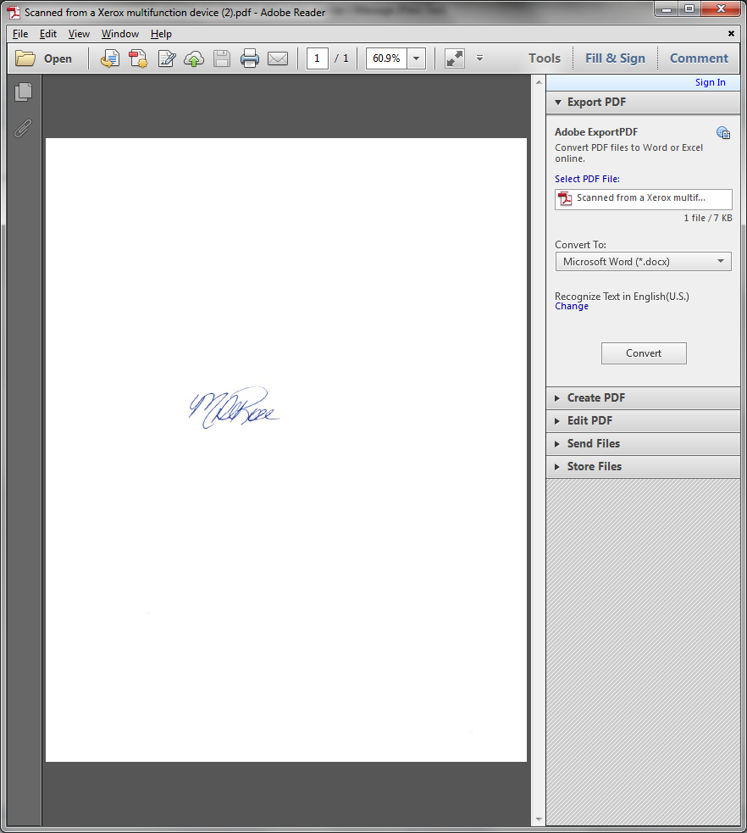**Clough Enercore Limited**

Mona DeRose

Manager, Human Resources

(403) 523-2009

I have read, understand and having had a reasonable opportunity to obtain legal advice hereby voluntarily accept the terms of employment described above as constituting a binding employment agreement between me and Clough Enercore Limited.

**ACCEPTANCE:**

________________________________________

Employee

**Schedule “A”**

**Job Description**

**CONFIDENTIALITY, CONFLICT OF INTEREST AND**

**OWNERSHIP OF INFORMATION AGREEMENT**

This Agreement made as of the Xst Day of Month, 2021

**BETWEEN:**

**CLOUGH ENERCORE LIMITED** (“Company”)

**- And -**

**(“EMPLOYEE”)**

**WHEREAS** the parties hereto agree that it is in their mutual interest to enter into a business relationship;

**AND WHEREAS** the parties agree that to do so it is necessary and desirable for them to enter into this Confidentiality, Conflict of Interest and Ownership of Information Agreement.

**NOW THEREFORE** in consideration of the mutual covenants and agreements herein contained and for other good and valuable consideration provided to the Employee, the receipt and sufficiency of which is hereby acknowledged, the parties agree as follows:

1. **CONFIDENTIALITY AND OWNERSHIP OF INFORMATION**
   1. The Employee acknowledges that they will acquire information which is confidential to the Company and is its exclusive property. This information (the “Confidential Information”) includes but is not limited to the following:
   2. Trade secrets including but not limited to the Clough Enercore Limited Technology;
   3. Lists of present and prospective customers and buying habits;
   4. Purchase requirements;
   5. Pricing and sales policies and concepts;
   6. Financial information;
   7. Business plans, forecasts and market strategies;
   8. Discoveries, inventions, research and development, formulas, applications and technology;
   9. List of present and prospective trades, contractors, sub-contractors and consultants;
   10. Knowledge of individual employee’s skills, experience, expertise and competence;
   11. Knowledge of individual customer contact personnel and decision makers, their contact information, needs, habits and preferences.
   12. Any secret, trade secret, or engineering and technical know-how, process, computer software and related material owned, licensed or marketed by the Company or its clients, marketing strategies, customer requirements, customer lists, employee’s compensation, methods or doing business, financial affairs of the Company and other business information belonging to the Company;
   13. Such information as a director, officer, manager or senior employee of the Company may from time to time designate to the Employee as being Confidential Information.
   14. The Employee acknowledges the Confidential Information could be used to the detriment of the Company and disclosure could cause the Company irreparable harm. Accordingly, the Employee undertakes to treat all Information with the utmost confidentiality and not disclose it to any third party or to use it for any purpose during or after the Employee’s employment, except as may be necessary in the proper discharge of the Employee’s duties, or with the prior written permission of the President of the Company.
   15. The Employee shall promptly disclose in writing to the Company all improvements, inventions, designs, ideas, copyrightable works, discoveries, trademarks, copyrights, trade secrets, formulas, processes, techniques, know-how, and data pertaining to the Enercore Technology (all collectively referred to as “Inventions”), made or conceived or reduced to practice or learned by the Employee during the term of the Employee’s employment, whether or not patentable, either alone or jointly with others, which are related to or useful in the actual or anticipated business of the Company or result from the tasks assigned to the Employee by the Company or result from the use of premises or equipment owned, leased or contracted for or by the Company. The Employee agrees that all such Inventions shall be the exclusive property of the Company and the Company shall be the sole owner of all patents copyrights and other rights in connection therewith. The Employee waives any moral rights he may have by virtue of the *Copyright Act* (Canada) or similar law.

1.4 All notes, data, tapes, reference items, sketches, drawings, memoranda, records, diskettes, formula, processes and other materials which are repositories of any of the Information or Inventions relating to the Company’s business which were produced by the Employee or came into the Employee’s possession through the Employee’s employment, (the “Materials”) belong exclusively to the Company. The Employee agrees to turn over to the Company all copies of any Materials in the Employee’s possession or under the Employee’s control, forthwith, at the request of the Company and in any event the Employee agrees to turn over all copies of any Materials in the Employee’s possession on the termination of the Employee’s employment with the Company whether the Employee’s employment is terminated by the Employee or the Company, with or without cause.

1. **CONFLICT OF INTEREST**

2.1 The Employee agrees that he will not directly or indirectly accept or offer gifts, bribes, goods, or services (“gifts”) that fall outside routine business practices where such gifts may influence or be perceived as an attempt to influence a customer, potential customer, supplier, potential supplier, regulator or government agency. Where the Employee has any doubt as to whether a gift falls outside routine business practice he must seek advice and direction from his immediate supervisor or the Company President.

2.2 The Employee represents that he has no other business interests and is not currently involved as an owner, employee, partner, consultant or advisor in any business or non-profit organization which has not been disclosed to the Company. Ownership of less than 5% of the shares of a publically traded company shall not be considered to be a business interest which is covered by this provision.

2.3 During the course of his employment with the Company the Employee agrees that he will disclose any outside employment, consulting assignments, board appointments or advisory positions to the Company.

1. **INJUNCTIVE RELIEF**

3.1 Employee agrees that the Company has a material interest in maintaining the confidentiality of its Confidential Information, Inventions and Materials and preserving the relationships it has developed with its customers, trades, contractors, sub-contractors, employees and consultants against impairment by activities of a former employee. Accordingly, the Employee agrees the restrictions and covenants contained in paragraph (1) “Confidentiality and Ownership of Information”, and paragraph (2) “Conflict of Interest” are reasonably required for the protection of the Company’s goodwill and by signing this Agreement, the Employee agrees that the Company is entitled to enforce such restrictions and covenants by means of temporary and permanent injunctive relief as well as other remedies which the Courts may consider appropriate.

1. **GENERAL**

4.1 This Agreement shall be governed by the laws in force in the Province of Alberta. If any provision of this agreement is wholly or partially unenforceable, for any reason, such unenforceable provision or part thereof, shall be deemed to be omitted from this agreement without in any way invalidating or impairing the enforcement of any of the other provisions of this agreement.

4.2 The rights, duties and obligations under this Agreement shall survive the termination of the Employee’s term of service to the Company and shall inure to the benefit of and be binding upon the Employee’s heirs and personal representatives as well as the successors and assigns of the Company.

4.3 The Employee has read and understood this Agreement and acknowledges having received an opportunity to obtain independent legal advice prior to signing this Agreement.

4.4 The Employee acknowledges having received a fully executed copy of this Agreement.

**IN WITNESS WHEREOF** the parties hereto have executed this Agreement this _____ day of ____________________, 2021.

|  |  |  |
| --- | --- | --- |
|  |  |  |
| Mona DeRose  Clough Enercore Limited |  | Employee |