Project Name: | E2O Asset Services – East Coast based projects
Position:
Employee Name:
Email Address:
Contact Mobile #
Date:

The Following Personal Protective Clothing and Equipment will be Provided Upon First Issue,
PLEASE ENSURE IT IS ALL TAKEN TO SITE WHEN YOU MOBILIZE
PLEASE ENSURE INDICATION OF MENS OR LADIES THEN ENTER YOUR SIZE. QTY ALLOCATION NOT TO BE CHANGED
PREFERENCE OF SHIRT & TROUSERS OR OVERALLS. YOU WILL ONLY BE PROVIDED WITH ONE CHOICE
PLEASE CONSIDER YOUR ROLE RESPONSIBILITES
Size Options & Measurements can be viewed at the above website
ITEM |  | CODE  Please Circle | SIZE | QTY | STOCK  (WW Use Only)
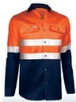 | LONG SLEEVE ULTRA COOL COTTON SHIRT WITH REFLECTIVE TAPE, O/N (E20 asset services EMBROIDERY)  Mens Sizing: 2XS - 5XL  Ladies Sizing: 6 - 18 | MENS: RGSLR155-ON  LADIES: RGLSLR155-ON |  | 5 | CLOUGH  WI
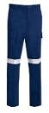 | LIGHTWEIGHT COTTON DRILL CARGO TROUSERS WITH REFLETIVE TAPE, NAVY  Mens Sizing: 77R - 132R, 87S – 132S, 74L-94L  Ladies Sizing: 6 - 18 | MENS: RGTCR124  LADIES: RGLTR124 |  | 5 | CLOUGH  WI
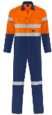 | HIGH VIS LIGHT WEIGHT COTTON DRILL OVERALL (REFLECTIVE – TWO TONE) (E20 asset services EMBROIDERY)  Mens Sizing: 77R - 132R, 87S – 132S, 74L-94L | MENS: RGCR124TT |  | 5 | CLOUGH  WI
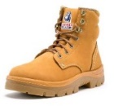 | STEEL BLUE LACE AND ZIP BOOTS (WHEAT)  Sizes: 4 - 14  Note: Will Substitute with RIGGERS TORNADO V2 LACE UP / ZIP SIDE BOOTS (WHEAT) if N/A  Sizes: 5 - 13 | BSB332152 |  | 1 | CLOUGH  WI
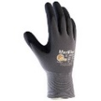 | MAXIFLEX ELITE PALM COATED KNITWRIST GLOVES  Sizes: S - 2XL | IP-ATG34-274 |  | 1 | CLOUGH  WI

PLEASE SELECT YOUR PREFERENCE OF JACKET. PLEASE CONSIDER YOUR ROLE RESPONSIBILITES
YOU WILL ONLY BE PROVIDED WITH ONE CHOICE
ITEM |  | CODE  Please Circle | SIZE | QTY | STOCK  (WW Use Only)
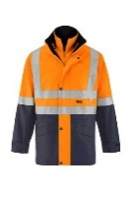 | 4-IN-1 SAFETY REFLECTIVE JACKET + REVERSIBLE VEST  Sizing: S - 6XL  Polyester PU coated outer with polyester ling. waterproof. Reversable polar fleece vest – e2o asset services Embroidered | SRJV-ON |  |  | CLOUGH  WI
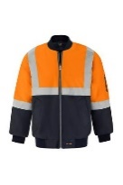 | FLYING JACKET POLYESTER PU COATED  Sizing: S-6XL  Polyester PU coated outer with quilted lining, waterproof all sealed seams, ribbed knit collar & cuffs – e2o asset servcvices Embroidered | FJRP-ON |  |  | CLOUGH  WI

Quantity Allocation not to be changed
ITEM |  | CODE  Please Circle | QTY | STOCK  (WW Use Only)
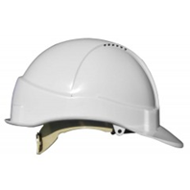 | VENTED HARD HAT  WITH XL e2o asset services LOGO - WHITE | SSTA570C207-WH | 1 | CLOUGH  WI
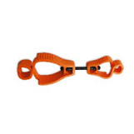 | INTERLOCK GLOVE CLIP  (FLURO ORANGE) | ASIILN-OR | 1 | CLOUGH  WI
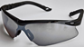 | PROGARD TERMINATOR SAFETY GLASSES  (SMOKE) | RGEW-PG05 | 1 | CLOUGH  WI
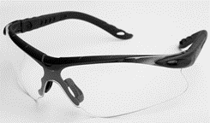 | PROGARD TERMINATOR SAFETY GLASSES  (CLEAR) | RGEW-PG05 | 1 | CLOUGH  WI
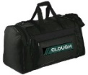 | MAGNUM SPORT BAG IN BLACK  (WITH e2o asset services LOGO) | EPB260A-BK | 1 | CLOUGH  WI

Confirmation of Receival and Items Fitting
Print Name | Signature | Date
Work Wear Rep. | Signature | Date
Additional Comments:
Jackets will only be provided in the seasons required.

